Schreiben 1 Name:
Meine Wochentage

Begründe, was dir an deinen Wochentagen gut gefällt.
Ich mag den Montag, weil ___________________________________________________________________

________________________________________________________________________________________________________

Ich mag den Dienstag, weil _________________________________________________________________

________________________________________________________________________________________________________

Ich mag den Mittwoch, weil ________________________________________________________________

________________________________________________________________________________________________________

Ich mag den Donnerstag, weil _____________________________________________________________

________________________________________________________________________________________________________

Ich mag den Freitag, weil ___________________________________________________________________

________________________________________________________________________________________________________

Ich mag den Samstag, weil _________________________________________________________________

________________________________________________________________________________________________________

Ich mag den Sonntag, weil __________________________________________________________________

________________________________________________________________________________________________________

Warum magst du den Frühling?
Ich ____________________________________________________________________________________________________

_________________________________________________________________________________________________________

Schreiben 2 Name:
Mein Start in den Morgen

Erzähle, wie du den Morgen meisterst.
Wenn der Wecker läutet, ___________________________________________________________________

________________________________________________________________________________________________________

Wenn die Zahnpasta leer ist, ______________________________________________________________

________________________________________________________________________________________________________

Wenn es keine Konfitüre hat, ______________________________________________________________

_______________________________________________________________________________________________________

Wenn ich einen Test in der Schule habe, _______________________________________________

________________________________________________________________________________________________________

Wenn ich zu spät aufgestanden bin, ______________________________________________________

________________________________________________________________________________________________________

Wenn mein Lieblings-T-Shirt in der Wäsche ist, __________________________________

________________________________________________________________________________________________________

Wenn es draussen regnet, ___________________________________________________________________

________________________________________________________________________________________________________

Bist du eine Lerche (eher am Morgen fit) oder eine Eule (eher am Abend fit)?

_______________________________________________________________________________________________________

Schreiben 3 Name:
Wenn meine Welt ein Märchen wäre…

Erfinde Märchenanfänge mit Personen oder Dingen aus deinem Leben!
Zum Beispiel:
Es war einmal ein Fahrrad, das hatte ein Regendach.

Es war einmal __________________________________________________________________________________

________________________________________________________________________________________________________

Es war einmal __________________________________________________________________________________

________________________________________________________________________________________________________

Es war einmal __________________________________________________________________________________

________________________________________________________________________________________________________

Es war einmal __________________________________________________________________________________

________________________________________________________________________________________________________

Es war einmal __________________________________________________________________________________

________________________________________________________________________________________________________

Es war einmal __________________________________________________________________________________

________________________________________________________________________________________________________

Es war einmal __________________________________________________________________________________

________________________________________________________________________________________________________

Es war einmal __________________________________________________________________________________

________________________________________________________________________________________________________

Schreiben 4 Name:
Ich packe in den Rucksack …

Zähle auf, was du einpacken würdest. Bleibe bei möglichen Dingen!
Ich packe in den Rucksack: ein Getränk, __________________________________________________

________________________________________________________________________________________________________

________________________________________________________________________________________________________

Ich packe in den Koffer: ______________________________________________________________________

________________________________________________________________________________________________________

________________________________________________________________________________________________________

Ich packe in die Velotasche: _________________________________________________________________

________________________________________________________________________________________________________

________________________________________________________________________________________________________

Ich packe in die Strandtasche: ______________________________________________________________

________________________________________________________________________________________________________

________________________________________________________________________________________________________

Ich packe in die Sporttasche: ________________________________________________________________

________________________________________________________________________________________________________

________________________________________________________________________________________________________

Ich packe in die Hosentasche: _______________________________________________________________

________________________________________________________________________________________________________

________________________________________________________________________________________________________

Schreiben 5 Name:
Sammle Wörter, die zu dir passen …

Du kannst die Wortart wählen:
Deine Personen und Dinge, was du gerne machst, wie du bist…
A
B
C
D
E
F
G
H
I
J
K
L
M
N
O
P
Q
R
S
T
U
V
W
X
Y
Z

Schreiben 6 Name:
Bilder und Sätze …

Schreibe zu jedem Bild einen Satz mit mindestens 6 Wörtern.
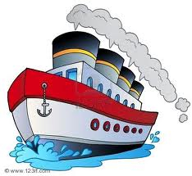 | ______________________________________________________________________________  ______________________________________________________________________________  ______________________________________________________________________________  ______________________________________________________________________________
______________________________________________________________________________

______________________________________________________________________________

______________________________________________________________________________

______________________________________________________________________________

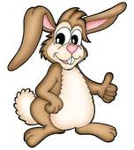 | ______________________________________________________________________________  ______________________________________________________________________________  ______________________________________________________________________________  ______________________________________________________________________________
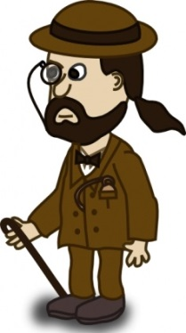 | ______________________________________________________________________________  ______________________________________________________________________________  ______________________________________________________________________________  ______________________________________________________________________________
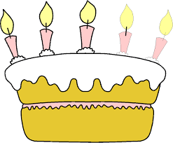 | ______________________________________________________________________________  ______________________________________________________________________________  ______________________________________________________________________________  ______________________________________________________________________________

Schreiben 7 Name:
Fragen und Antworten …

Schreibe zu jedem Bild einen Antwortsatz mit mindestens 6 Wörtern.
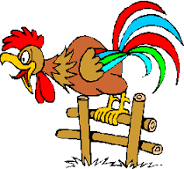 | Was sieht der Hahn wohl?  ______________________________________________________________________________  ______________________________________________________________________________  ______________________________________________________________________________
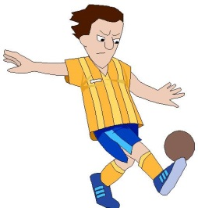 | Wofür trainiert der Junge?  ______________________________________________________________________________  ______________________________________________________________________________  ______________________________________________________________________________
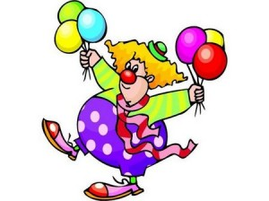 | Wo verkauft der Clown seine Ballons?  ______________________________________________________________________________  ______________________________________________________________________________  ______________________________________________________________________________
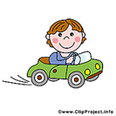 | Wohin fährt der Junge?  ______________________________________________________________________________  ______________________________________________________________________________  ______________________________________________________________________________
Wem gehört dieses Sparschwein?

______________________________________________________________________________

______________________________________________________________________________

______________________________________________________________________________

Schreiben 8 Name:
Was ist drin?
Vermute, was in den Behältern drin ist! Schreibe pro Bild mehrere mögliche Dinge!
______________________________________________________________________________

______________________________________________________________________________

______________________________________________________________________________

______________________________________________________________________________

        

